

**KAUNAS UNIVERSITY OF TECHNOLOGY**

**FACULTY OF INFORMATICS**

**T120B166 Development of Computer Games and Interactive Applications**

Mario Bros clone

Edgar Reis IF 7-1

Date: *2020-02-02*

## Kaunas, 2020

# Table of figures:

Figure 0. 50 environmental elements.……………………………………….…………Page 4

Figure 1. Directional li.ght…………………………………………………………… Page 5

Figure 2. Spot light….………………………………………………………………... Page 5

Figure 3. Point light.…………………………………………………………………....Page 6

Figure 4. Point light ………………..…………………………………………………..Page 6

Figure 5. Spot light ………………………………………………………………….....Page 6

Figure 6. Spot light ………………………………………………………………….…Page 6

Figure 7. Materials1..……………………………………………………………….… Page 7

Figure 8. Materials 2……………………………………………………………………Page 7

Figure 9. Materials 3………………………………………………………………….. Page 7

# Description of game

The topic I choose for the game is clone of 1985 Mario Bros game. This is a 2D platformer game. It contains 8 Worlds, each contains 4 levels, in 4th level of each world player has to defeat the Boss enemy. Few levels have different mechanics from others, it’s underwater levels. In these levels player has to swim, rather than run and jump. On his way through the levels, player obtains points from killing enemies, finishing levels with as much time remaining as possible, collecting coins or objects which might change player’s form. There are three types of such objects. Super mushroom – doubles size of Mario, prevents him from dying then touching and enemy, allows him to break “Brick” game objects, which sometimes contain hidden valuables. Fire flower- once Mario is in Super Mario forms, all other Super Mushrooms turn into Fire flowers, which turns Mario into Fire Mario form. There is only one difference from Super Mario and Fire Mario forms – in Fire Mario form player is able to throw fire balls, which kill any enemy on touch. Super star – turns Mario into Invincible Mario form. When Mario is in this form he is able to kill any enemy just by touching it, but this form disappears after short period of time. Game has various types of enemies. Goombas – most recently met type of enemies. They just move in one direction until they bump into something and change movement direction, they are killed by stomping them. Koopa troopas (further KT) – similar type of enemies as Goombas, but once stomped, they hide in their shell (KTs are turtles) for a short period of time. If player pushes this shell it will rapidly move and kill any enemy or player himself on touch, but if it is left static KT will come out of the shell and act same as before stomping. KT has different variations – jumping KT, flying KT, KT which moves between invisible bounds. Lakitu – an enemy which moves above ground and throws Spinny eggs, he is killed by stomping. Spinny egg – enemy similar to Goomba, apart the fact, that they can’t be stomped and they appear only from Lakitu. Hammer bros – enemies which jump between few levels of bricks and throw hammers into Mario. If Mario doesn’t pass or kill them during certain amount of time, they start moving towards him. They are killed by stomping them. Bullet Bill – an enemy which always moves in one direction and passes through any obstacles. He is killed by stomping. Cheep cheep – acts same as Bullet Bill, but since it’s an underwater level enemy he can’t be stomped. In some levels Cheep cheeps jump out from the ground. Squid – underwater levels enemy, then around Mario he swims randomly, but once Mario moves away, Squid starts chasing him. Piranha plant – an enemy which periodically comes out of the pipes, he can’t be stomped. Bowser – Boss of each level, fires projectiles in Mario, since level 4 starts throwing hammers, he can’t be stomped.

# Laboratory work #1

List of tasks (main functionality of your project)

1. Create at least 50 environmental elements.
2. Use at least 10 different sounds and at least 5 pieces of background music.
3. Create at least 10 different light sources.
4. Create 20 different materials.

# Solution

Task #1. *Create at least 50 environmental elements.*

Game contains a lot of various environmental elements. In 32 main and 10 hidden levels palyer can meet 14 different types of enemies. Other objects are: pipes - can lead player to hidden level or be a place where enemies hide, bricks – usually just a platform element for player and enemies to walk on, but sometimes player may find valuable objects there, question blocks – objects which has valuable collectables hidden in them, coins – increase amount of players points, super mushroom, fire flower, super star – turns Mario into more powerful form, trees – allow player to climb into hidden level and etc.

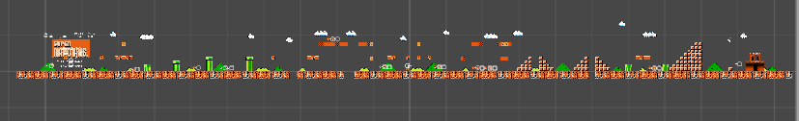

Figure 0. 50 environmental elements

Task #2. *At least 10 different sounds and 5 pieces of background music.*

Game has 4 types of levels (overworld, underworld, sea and castle) each having it‘s own background music. When game timer reaches 100, player can hear different background music indicating that he is running out of time. After that speed of background music increases. Also there are background music for player entering or leaving hidden level, completing the level, finishing stage, dying, losing the game, Mario being in Invincible Mario form.

Game has sounds for following events - jump, breaking the brick, collecting the coin, collecting super mushroom, fire flower or super start, reaching a flag pole at the end of a level, throwing fire ball, stomping an enemy, getting one extra life, boss fire spit, boss falling into lava, appearance of super mushroom or fire flower out of the question block, hammer throw.

Each sound has default settings.

Task #3. Create at least 6 different light sources.

Light sources are created in separate project, since Mario is a 2D game. Created lights have following properties:

1 – Directional light, color: FFF4D6, intensity : 2.

2 – Point light, color: FF0000, intensity : 40.

3 – Point light, color: 00FF50, intensity : 3.

4 – Spot light, color: FF6600, intensity : 5, spot angle : 30

5– Spot light, color: FFFFFF, intensity : 6, spot angle : 30

6 – Spot light, color: FFFFFF, intensity : 10, spot angle : 73,2

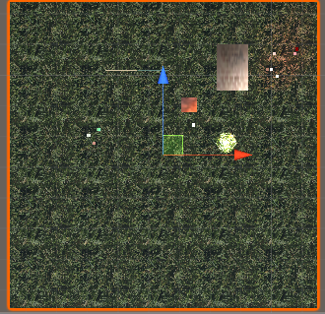

Figure 1. Directional light

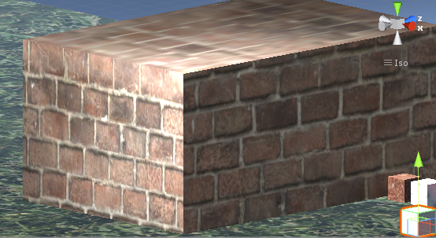

Figure 2. Spot light

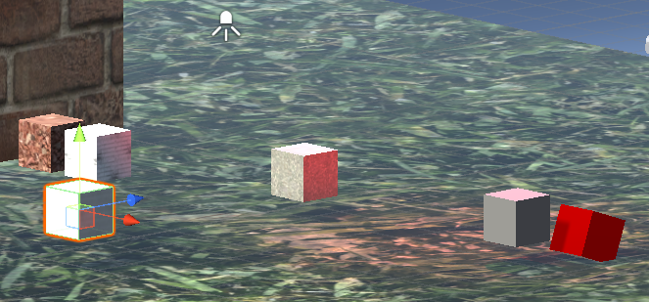

Figure 3. Point light

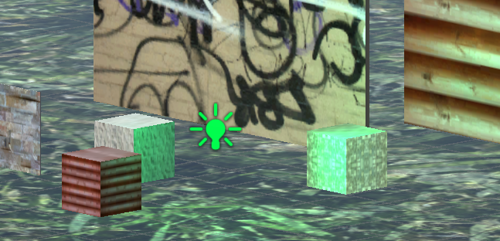

Figure 4. Point light

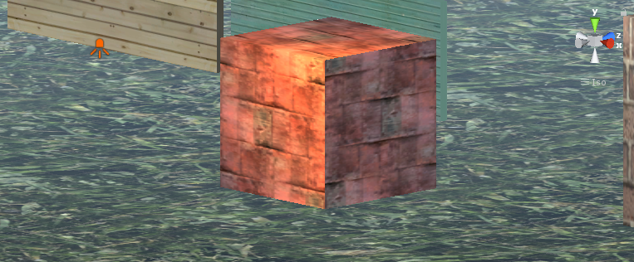

Figure 5. Spot light

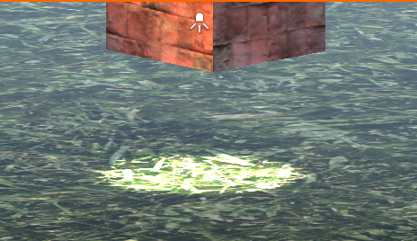

Figure 6. Spot light

Task #4. Create 20 different materials

Materials are created in separate project, since Mario is a 2D game. Created materials have just a plain color, various textures of bricks or wood and few others. Materials have two types of shaders: standard and nature/tree soft occlusion leaves.

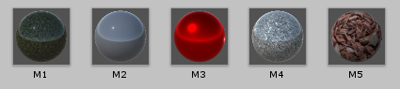

Figure 7. Materials 1

Figure 8. Materials 2

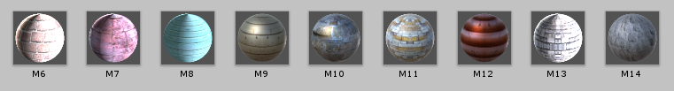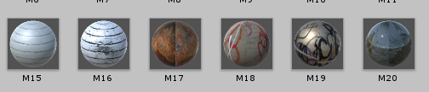

Figure 9. Materials 3

Task #5. Change music in 3 places depending on player’s position.

Task was implemented by editing global audio source’s script. Following code was added:

if (Mario_script.PositionX >= 62 && Mario_script.PositionX <= 89)

{

if (audioSource.clip != UnderWorldMain)

{

audioSource.clip = UnderWorldMain;

audioSource.Play();

}

}

else if (Mario_script.PositionX > 89)

{

if (audioSource.clip != Sea)

{

audioSource.clip = Sea;

audioSource.Play();

}

}